From Disability to Entrepreneurship
Rehana Batool is a resident of Chak 63, Union Council 50 MB. She completed her primary education but faced significant challenges in life due to a physical disability in her left leg. She is married and lives with her husband and ten children, including six daughters and four sons. Her husband works as a casual laborer and earns an irregular income, making it difficult for the family to meet its growing needs.
Managing a household of twelve members on a limited and uncertain income was a constant struggle for the family. It was often difficult to afford education, healthcare, and other necessities for the children. Despite this, Rehana ensured that all of her children attended private schools, as she believed education was the key to improving her family's future.
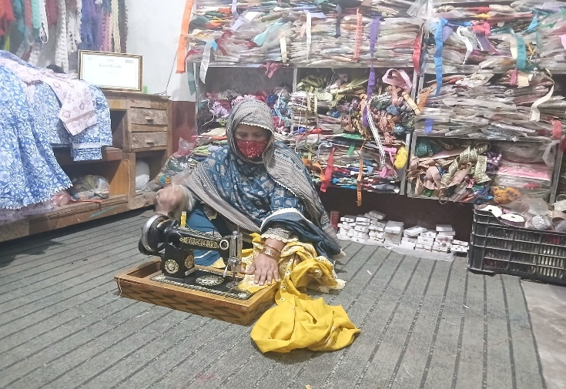
Government of Punjab, with assistance of IFAD, started Southern Punjab Poverty Alleviation Project (SPPAP) to improve the livelihoods of poor and vulnerable households in the region. Through community mobilization activities in her village, Rehana became a member of the local community organization and started participating in project activities. Seeing her interest and willingness to work, the project selected her for vocational skills training in Dress Designing during the year 2023.
This training became a turning point in Rehana's life. She completed the course and used her training stipend to purchase a sewing machine, through which she started dress designing and stitching services from her home. Later, she also accessed a revolving fund loan of PKR 50,000 to purchase additional material and expand her work further.
Along with the vocational training, Rehana also received two goats under the project's livestock component. The goats reproduced over time and gave birth to four offsprings. She sold one offspring for PKR 35,000 and used the income to support her household and business. Currently, she owns five goats including the original animals and their offsprings.
With time, Rehana's dress designing business gained popularity in the community. She started keeping raw material at home so customers could buy fabric and accessories directly from her, which gave her an additional profit margin of 15-20 percent along with her stitching income.
As demand for her work increased, she expanded her business further and established a shop for ready-made garments in Model Bazaar, District Khushab. She started purchasing cloth at wholesale rate and converting it into stitched garments of various sizes, which she sold at higher prices. Today, her dress design and garment business generates an average monthly income of PKR 35,000. After deducting around PKR 15,000 in monthly expenses, she is left with a net profit of PKR 20,000 every month.
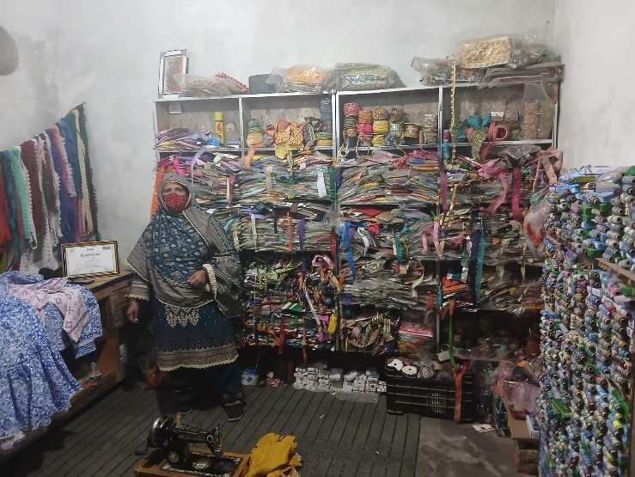
This income has changed the economic condition of her household considerably. Two of her daughters have already been married, and a major portion of the marriage expenses was covered through her business earnings. She also contributed towards the completion of her house, including construction of an additional room.
Rehana is also part of a community savings committee with other women of her locality, through which she is saving for the marriages of her remaining four daughters.
Apart from her own business, Rehana is also teaching her dress designing skills to her daughters and other girls of the village so that they may also learn an income-generating skill in future. She advertises her products through WhatsApp groups, and word of mouth from her customers have also helped her get new clients over time.
Today, Rehana Batool stands as an inspiring example of resilience, determination, and entrepreneurship. Despite facing physical disability and financial hardships, she successfully transformed project support into a sustainable livelihood. Her journey demonstrates how vocational skills training, access to financial resources, and personal commitment can empower vulnerable women to improve their economic conditions, support their families, and become agents of positive change within their communities.

